Team ID : SWTID-2026-9715
Team Size : 5

Team Leader : MUKESH K :6163@velsrscollege.com
Team member : JUDITHSMILER Y:6137@velsrscollege.com
Team member : RAMKUMAR S:6181@velsrscollege.com
Team member : SAMEER R:6191@velsrscollege.com
Team member : DANIEL SANJAY S A:6098@velsrscollege.com

Project Description
Creating engaging social media content with appropriate captions and trending hashtags is time-consuming for content creators, marketers, and social media managers. Users often spend significant time crafting the perfect caption, researching relevant hashtags, and ensuring content fits within platform character limits across differentsocialmediaplatforms.

Social Mood Matcher addresses this challengethrougha GenAI-powered social media content generation platformthat delivers personalized, sentiment-awarecaptions and trending hashtags optimized for different platforms. Using advanced image analysis with BLIP for image captioning, DistilBERT for sentiment analysis, and optionally Google Gemini 2.5 Flashfor enhanced quality, theplatformanalyzes uploaded images todetectmoodandvisualcontext.

The platform helps content creators generate engaging captions in multiple styles (casual, aesthetic, professional, playful), provides curated 2024 trending hashtags organized by category and sentiment, and ensures all content fits within platform-specific character limits for Twitter/X (280 chars), Instagram (2,200 chars), and Facebook (63,206 chars). Social Mood Matcher transforms social media content creation into an intelligent, efficient process through its smart sentiment detection, adaptivecaptiongeneration,andmulti-platformexportcapabilities.

Use Case Scenarios

Scenario 1: Food Photography with Mood Detection
A food blogger uploadsa cozy photo of ahomemade soup. The AI analyzesthe image using BLIP to understand the visual content ("bowl of soup on wooden table")

DistilBERTtodetectthesentiment("cozy","warm"). Thesystemgeneratesacaptionin the user's selected style (e.g., "Nothing beats a warm bowl of homemade soup on a chilly evening") and suggests relevant hashtags (#FoodPhotography #CozyVibes #Homemade #ComfortFood). Content is auto-formatted for the selected platform (Twitter) and fitswithinthe 280-characterlimit.

Scenario 2: Travel Content with Multi-Style Options
A travel influencer uploads a sunset beach photo. The platform detects the mood as "peaceful" and "aesthetic". Using the Gemini-enhanced mode, the system generates multiple caption variants: aesthetic ("Golden hour whispers stories only the ocean knows"), punchy ("Sunset state of mind"), and casual ("Beach sunsets hit different"). The user can preview all variants, select their favorite, and get platform-optimized hashtags (#TravelPhotography #SunsetVibes #BeachLife #GoldenHour) with smart truncation to fit Instagram'sformat.

Scenario 3: Brand Content with Character Limiting
A marketing professional uploads a product photo for a luxury brand. The AI detects "luxury" and "elegant" sentiments. The system generates a professional-style caption with no emojis, suggests premium hashtags (#LuxuryLifestyle #Premium #Elegance), and applies smart character limiting for Twitter. When the combined caption and hashtags exceed 280 characters, the platform intelligently truncates hashtags while preserving the full captionmessage, ensuring themostimportantcontentis retained.

Architecture Overview
Social Mood Matcher is an intelligent, modular platform designed to generate personalized, sentiment-awaresocial media content. It integrates a Streamlit frontend with multiple AI models including BLIP for image captioning, DistilBERT for sentiment analysis,andoptionally Google's Gemini2.5 Flashforenhancedquality outputs

Core Technologies
- Streamlit: Frontend frameworkforinteractiveUIand real-timecontent generation

- BLIP(Salesforce): Imagecaptioningmodelforunderstanding visualcontent

- DistilBERT: Sentimentanalysis modelfor mooddetection

- Gemini 2.5Flash(Optional): Enhanced AIforsuperiorcaption qualityandvisual intelligence
- Python-DOCX: Exportcaptionsto Worddocuments

- ReportLab: PDFgenerationwithprofessionalformatting

- Pillow(PIL): Imageprocessingandmanipulation

- Transformers(Hugging Face): AImodel integration andinference Gotyou Let’ scleanthisup andturn itintoaproper, presentation-readytable. Here’ syourComponent-Wise Architecture instructuredtableformat:
Component | Description
Frontend UI | Streamlit-based interface with image upload, style selection, platform targeting, and real-time result display. Features include sentiment badges, caption variants, and export options.
Image Sentiment Detector | Analyzes uploaded images using BLIP for scene understanding and DistilBERT for sentiment classification. Detects moods like happy, cozy, aesthetic, calm, luxury, adventurous, energetic, peaceful, romantic, andnostalgic.
Caption Generator | Creates engaging captions based on detected sentiment, selected style (casual, aesthetic, professional, playful), and image category (food, travel, nature, lifestyle). Uses template-based generation or Gemini API for enhancedquality.
Hashtag Engine | Recommends trending 2024 hashtags organized bycategory andsentiment. Supports priority-based selection using sentiment scoresandfilters bylengthforoptimalplatform compatibility.
Character Limiter | Ensures content fits platform limits (Twitter: 280, Instagram: 2,200, Facebook: 63,206 characters). Intelligently truncates captions and hashtags while preserving message  integrity.

Gemini AI Layer | Processes images using Gemini 2.5 Flash for
(Optional) | enhanced sentiment analysis, multiple caption
 | generation, and improved contextual
 | understanding.

Pre-requisites
- Python 3.10+:Download fromhttps://python.org

- Streamlit Framework:Seehttps://docs.streamlit.io

- Google AIStudio Account(Optional): ForGeminiAPIaccessat https://makersuite.google.com
- Required Python Libraries:Listed inrequirements.txt

- SystemRequirements: 4GB+RAMforAImodelinference

- Internet Connection: Formodel downloadsandoptional Gemini API

Project Workflow
The Social Mood Matcher project follows a structured 5-milestone development process, from initial setup to production deployment. Each milestonebuilds upon the previous onetocreateacomplete, production-readyapplication

EnvironmentSetup & Configuration
  - Setupprojectstructure andfileorganization

  - Configure environmentvariables and APIkeys

  - Installdependenciesandverifyinstallations

  - Test AImodel connectivity(local and Gemini

Core Services Development
  - Implement ImageSentiment Detectorservice

  - Build Caption Generatorwith multiplestyles

  - CreateHashtag Enginewith 2024 trends

  - Develop CharacterLimiterforplatformoptimization

  - IntegrateoptionalGeminiservicelayer

BackendImplementation
  - Designmodular Flask-stylearchitecturein Streamlit

  - Createutilityfunctionsforimageand text processing

  - Implementsessionstatemanagement

  - Builderror handlingandloggingsystems

UI Development
  - DesignresponsiveStreamlitinterface

  - Createimageuploadandpreviewfunctionality

  - Buildsidebarcontrols forstyle and platformselection

  - Implementtabbedresultsdisplay

  - Addexportand downloadfeatures

Testing& Optimization
- Performcomprehensivetesting acrossall feature OptimizeAImodelperformance and caching
- Validatecharacter limitingaccuracy

- Testmulti-platformcompatibilit
- Preparedeploymentconfiguration

MILESTONE 1: Environment Setup& Configuration
In thisfoundational stage, theobjective isto establishthedevelopment environmentand configureallnecessarytools,libraries,and AIservices required for SocialMood Matcher

Activity 1.1: ProjectStructure Setup
Create the project directory structure with proper organization for services, utilities,configuration, and tests

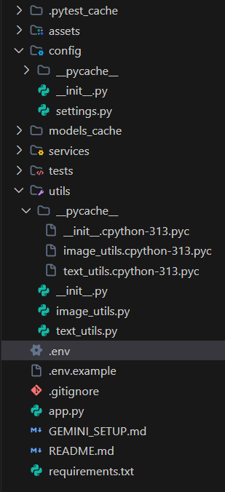

Activity 1.2: Install Dependencies
Install all required Pythonpackagesusingpip. The requirements.txtincludes Streamlit, Transformers,PyTorch,Pillow,and optionalGeminiAPIsupport

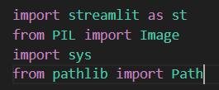

Activity 1.3: Configure Environment Variables
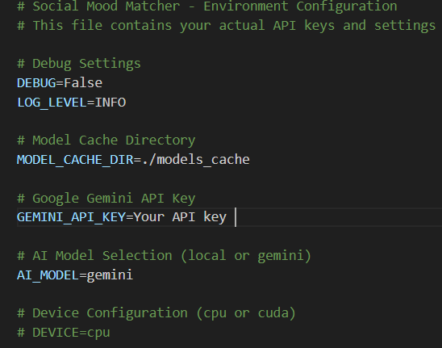
Setupthe.envfilewithnecessaryconfigurations. Thisincludesoptional GeminiAPIkey, modelcachedirectory, and debug settings.

Activity 1.4: Optional Gemini Setup
- Visit Google AIStudio:https://makersuite.google.com/app/apikey

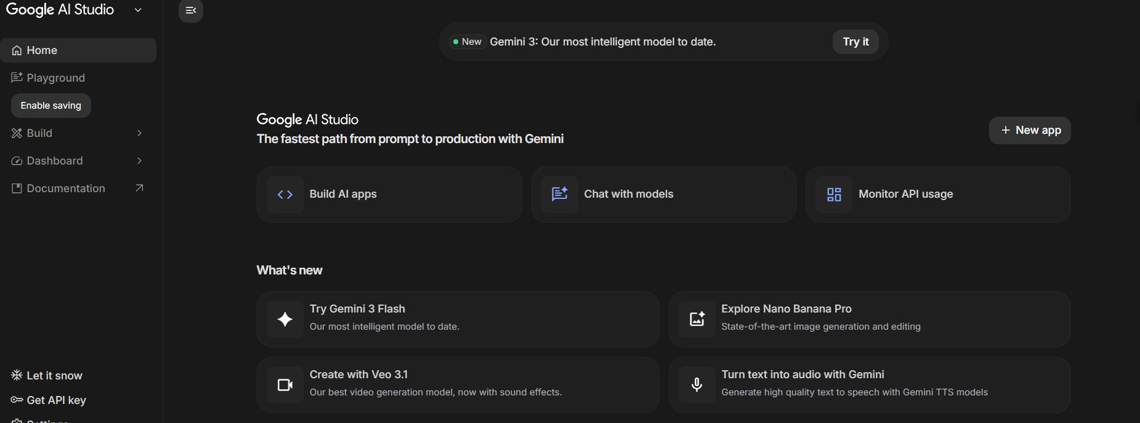
- Signinwith Googleaccount

- Click'CreateAPIKey' andcopy thegeneratedkey


- Addkeyto.envfile: GEMINI_API_KEY=your_key_here

- Set AI_MODEL=gemini in .env toenableenhancedmode

- Install google-generativeai package(included in requirements.txt)

MILESTONE 2: CoreServices Development
Thismilestonefocuses on building thecore AI-powered services that form thebackbone of Social Mood Matcher. Each service is designed as an independent, testable module withclear Responsibilities.

Activity 2.1: Image SentimentDetectorService
Create the image_sentiment.py service that uses BLIP for image captioning and
DistilBERT

forsentimentanalysis. Thisserviceisthefirststepinthecontentgenerationpipeline. Key Features:
- Load andcache BLIPimagecaptioningmodel

- Load andcache DistilBERTsentiment analysismodel

- Process imagesto extractvisualdescriptions

- Analyzesentimentfromimagecaptionsand visual cues

- Classifyinto10 moodcategories(happy,cozy,aesthetic,calm, etc.)

- Detect imagecategories (food,travel,nature,lifestyle)

- Returnconfidencescoresforalldetectedsentiments

Activity 2.2: Caption GeneratorService
Develop the caption_generator.py service that creates engaging captions based on sentiment,stylepreferences,and imagecontext.

Supported Styles:

    Style | Characteristics | Emoji Usage
Casual | Friendly, relaxed tone | Moderate (2-3)
Aesthetic | Poetic, artistic language | Minimal (0-1)
Professional | Polished, informative | None
Playful | Fun, energetic tone | High (3-5)

Activity 2.3: Hashtag Engine Service

Build thehashtag_engine.py service that provides curated, trending hashtags organized bycategory and sentiment. Includes 2024's most popular hashtags for maximum engagement.
Hashtag Categories:

- Food: #FoodPhotography,#Foodie,#InstaFood, #FoodLover, #Delicious

- Travel: #TravelPhotography,#Wanderlust,#TravelGram,#Explore, #Adventure

- Nature:#NaturePhotography,#NatureLover, #Landscape,#Scenic, #OutdoorLife

- Lifestyle: #LifestylePhotography,#DailyLife,#Moments, #Inspiration, #Aesthetic

Activity 2.4: Character LimiterService
Implement thecharacter_limiter.py service that ensuresall generated content fits within platform-specific characterlimitswhilemaintainingmessageintegrity

    Platform | CharacterLimit | Truncation Strategy
Twitter/X | 280 | Prioritize caption, truncate hashtags
Instagram | 2,200 | Rarely needed, full content usuallyfits
Facebook | 63,206 | Almost never needed

Activity 2.5: Optional Gemini Service Integration
Createthegemini_service.py for users who want enhanced AIcapabilities. This service provides superiorcaption quality,multiplevariants, and visual intelligencefeatures.

  - Enhancedsentimentdetectionwithhigheraccuracy

  - Multiplecaptionvariants(aesthetic,punchy,descriptive)

  - Visual intelligence:dominantcolors,detected objects

  - Compositiontipsforbetter photography

  - Morecreativeandcontextually relevantcaptions

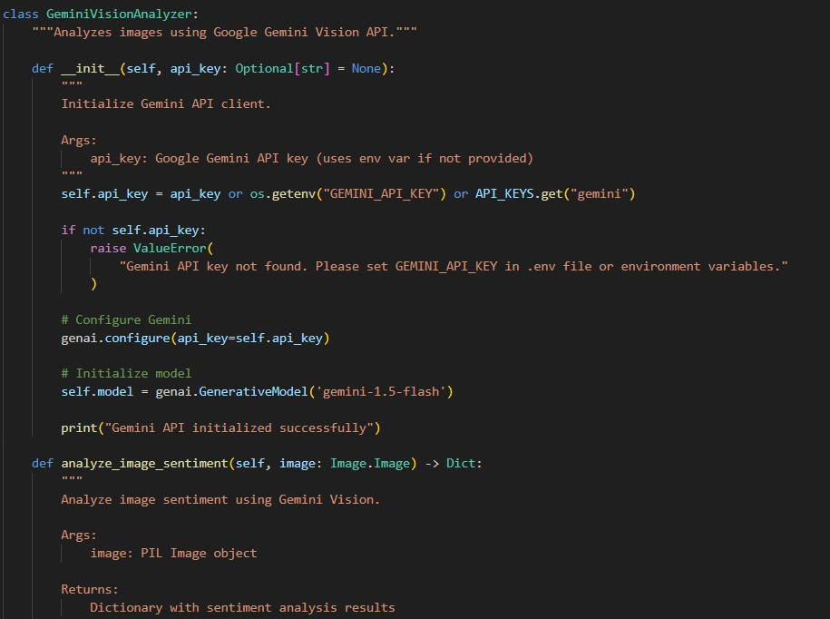
MILESTONE 3: Backend Implementation

This milestone integrates all services into a cohesive backend architecture within the Streamlit application. Focus on proper session state management, error handling, and efficient caching.

Activity 3.1: Session State Management
Implement proper Streamlit session state initialization to maintain user selections, generatedcontent,andapplicationstateacrossreruns.

  - generated_caption: Currentgeneratedcaption

  - generated_hashtags:Currenthashtag list

  - sentiment_result: Detected sentiment and metadata
  - caption_variants:Multiple captionoptions(Gemini mode)

  - visual_analysis:Visualintelligence data(Gemini mode)

  - history: List ofprevious generations

  - use_gemini:ToggleforGemini vslocalmodels

  - gemini_analyzer: Cached Gemini service instance

Activity 3.2: Service Initialization and Caching
Use Streamlit's @ st.cache_resource decorator to load AI models once and reuse across sessions. This significantly improves performance by avoiding repeated model loading.

  - ImageSentimentDetector:BLIPand DistilBERTmodels(~2GB)

  - CaptionGenerator: Template-basedgenerationsystem

  - HashtagEngine:Curatedhashtagdatabase

  - CharacterLimiter:Platform rules and truncationlogic

  - GeminiAnalyzer(Optional): GeminiAPIclient

Activity 3.3: Error Handling and Validation
Implement comprehensive error handling for file uploads, model inference, and API calls. Provideclearerrormessages andfallbackmechanisms.

- Invalidfileformat: Showsupportedformats (JPG, PNG,WEBP)

- Filesizetoolarge:Displaymaxuploadsize(10MB)

- Modelloadingfailure:Showretryoptionor usecached models

- Gemini APIerror:Automatically fallback to localmodels

- Emptygeneration:Retry withadjusted parameters

Activity 3.4: Image and Text Processing Utilities
Implement utility functions in utils/ directory for common image and text operations usedthroughouttheapplication.

image_utils.py: validate_image(),resize_image(),preprocess_for_model(), create_thumbnail()
text_utils.py: clean_text(), format_hashtags(), truncate_text(), smart_truncate_with_hashtags()

MILESTONE 4: UI Development

Createanintuitive, visuallyappealing Streamlit interfacewith responsive design, clear navigation,andreal-timefeedbackduring contentgeneration.

Activity 4.1: Main Layout Design
Design a two-column layout with image upload on the left and results display on the right. Includecustom CSSforenhanced visualappeal.

- Headerwithgradienttitleandsubtitle

- Sidebarforsettings(style, platform, hashtagcount, Gemini toggle)

- Leftcolumn:Imageuploadwithpreview

- Rightcolumn: Tabbedresults (Content,Visual Pro, History)

- Customcolorschemematchingbrand (purplegradient)

- Responsivedesignformobileanddesktop

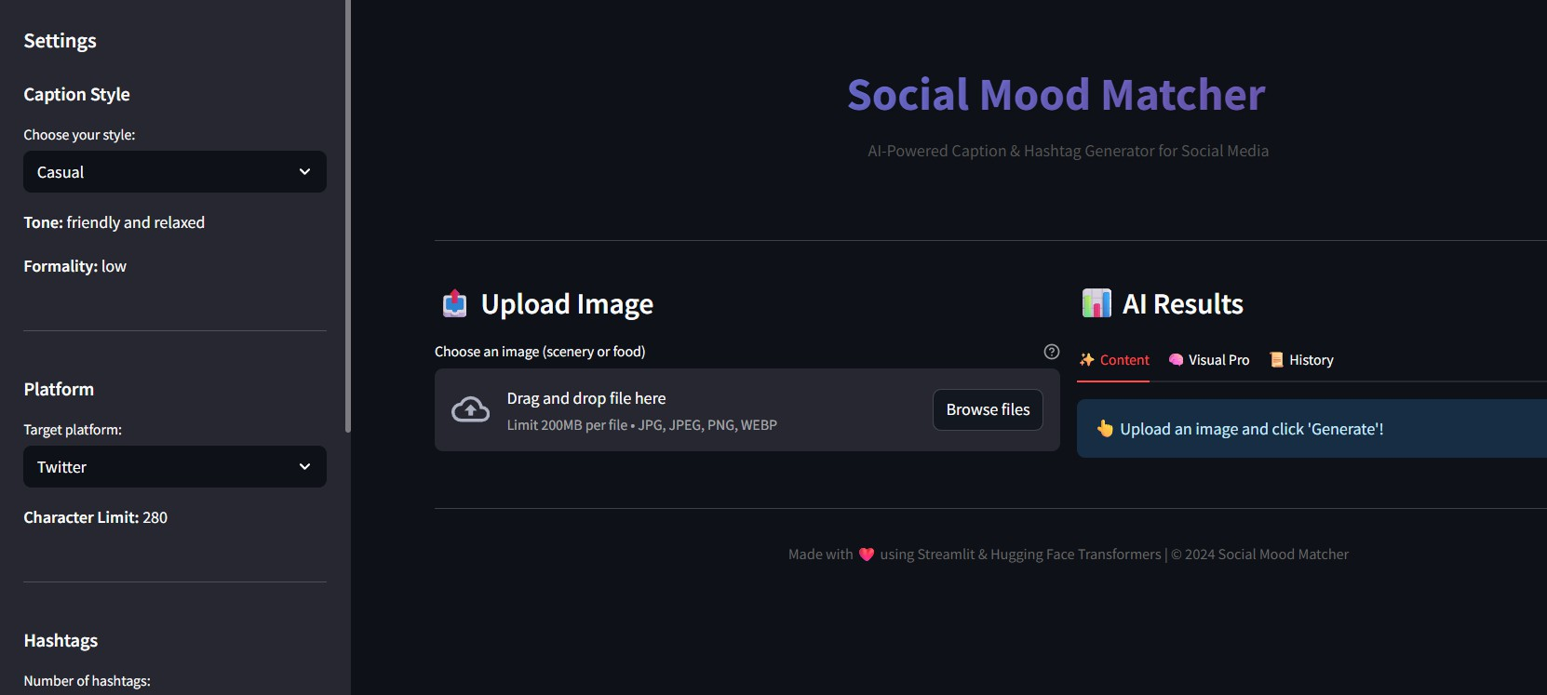
Activity 4.2: Sidebar Controls
Implementsidebarwithuser controlsforcustomizinggenerationparameters.

- Caption Style: Select from Casual,Aesthetic,Professional,Playful

- Platform: Choose Twitter/X,Instagram,orFacebook

- Numberof Hashtags: Sliderfrom 3 to15

- Use Gemini API: Toggleforenhanced vslocalmode

- AboutSection: Appdescriptionandfeatures

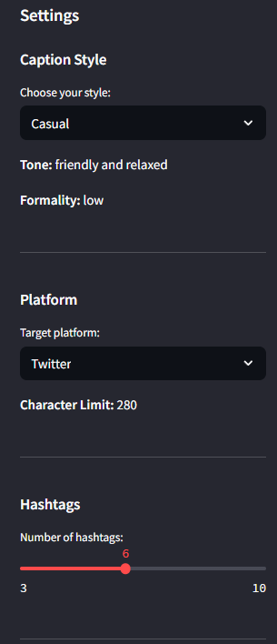

Activity 4.3: Results Display
Createtabbedinterfacefordisplayingdifferenttypes of results:

Content Tab: Sentiment badge, caption variants selector (Gemini), generated caption, hashtags,character count
Visual Pro Tab: Visual intelligence (Gemini only): dominant colors, detected objects, compositiontips
- History Tab: Previous 5 generations with sentiment and timestamp

Activity 4.4: Export Functionality
Add download button for exporting generated content as a text file. Content includes caption and hashtagsformattedforeasycopy-paste.

MILESTONE 5: Testing & Optimization

Comprehensive testing ensures reliability, accuracy, and performance. This milestone includes unit tests, integrationtests, and performanceoptimization.

Activity 5.1: Unit Testing
Test individual components using pytest framework. Each service should have comprehensive testcoverage.

- TestImageProcessor: Imagevalidation, resizing,preprocessing

- TestTextProcessor: Textcleaning,hashtagformatting,truncation

- TestCaptionGenerator: Captiongeneration forall stylesandsentiments

- TestHashtagEngine: Hashtagretrieval, filtering, priority-basedselection

- TestCharacterLimiter: Platform limits, smart truncation,edgecases

Activity 5.2: Integration Testing
Testthecompletepipelinefrom imageupload to finalcontentgeneration.

- Uploadimage → Sentimentdetection → Caption generation → Hashtag retrieval→
Characterlimiting

- Testwithmultipleimagetypes:food,travel,nature, lifestyle

- Verifyall captionstylesproduceappropriateoutputs

- Validatecharacterlimitsforallplatforms

- Test Gemini fallbackwhen APIfails

Activity 5.3: Performance Optimization
Optimizeapplicationperformanceforfasterresponsetimes andbetteruserexperience.

- Use@ st.cache_resourcefor model loading(preventsreloading)

- Implementimageresizingbeforemodelinference(fasterprocessing)

- Addloadingspinnersduring AIoperations(betterUX)

- CacheGemini APIclient to avoidrepeated initialization

- Optimizesessionstateupdatestominimizereruns

Expected PerformanceMetrics:

Operation | First Run | SubsequentRuns
Model Loading | 30-60seconds | Instant (cached)
Image Analysis | 3-5 seconds | 2-3 seconds
Caption Generation | 1-2 seconds | 1-2 seconds
Gemini API Call | 2-4 seconds | 2-4 seconds
Total (Local Mode) | ~35-70 sec first | ~5-8 sec
Total (Gemini Mode) | ~5-10 sec | ~4-6 sec

Deployment Guide

Social Mood Matcher can bedeployed on multipleplatforms. This section covers Streamlit Cloud, and cloudplatforms(AWS/GCP/Azure).

Option 1: Streamlit Cloud (Recommended)
- Pushcodeto GitHubrepository

- Visithttps://share.streamlit.ioand signin

- Click'Newapp' and selectyourrepository

- Configuremainfilepath(app.py) and Pythonversion(3.10)

- Add secrets: Goto Advanced Se tings → Secrets
- Deploy andwait forbuildcompletion(~5 minutes)

Option 2: Cloud Platforms (AWS/GCP/Azure)
Deploy on cloud platforms for production-grade scalability and reliability. Use managed container services likeAWSECS,GoogleCloud Run,orAzureContainerInstances.
Troubleshooting Guide

Issue: Models not loading
  - Checkinternetconnectionfor first-timedownload

  - Verify MODEL_CACHE_DIR haswritepermissions

  - Ensuresufficient diskspace(~2GB)

  - Tryclearing cache: rm -rfmodels_cache/

Issue: Gemini API errors
  - Verify APIkeyiscorrectin .env file

  - Check APIquotaat GoogleAIStudio

  - Ensuregoogle-generativeaipackageis installed

  - Applicationautomatically fallsbacktolocal models

Issue: Session state issues
  - Clearbrowsercacheand reloadpage

  - Checkforpropersession state initialization

  - Verifyall sessionvariablesare defined

Issue: Character limit not working
  - Verifyplatformselection matchesexpected limit

  - Checksmart_truncate_with_hashtags() logic

  - Testwithdifferentcaption/hashtagcombinations

Issue: Image upload failures
  - Checkfileformat (JPG, PNG,WEBPonly)

  - Verifyfile size isunder10MB

  - Ensureimageisnotcorrupted
  - Trydifferentimageorresizebeforeupload

Conclusion
Social Mood Matcher revolutionizes social media content creation by delivering intelligent, AI-driven captions and hashtags tailored to image sentiment and user preferences. By combining BLIP for image understanding, DistilBERT for sentiment analysis, and optionally Gemini 2.5 Flash for enhanced quality, the system processes visual contentandgeneratesengaging,platform-optimizedsocialmediaposts.

Frommodular servicearchitectureto intelligent content generationand responsive UI design, Social Mood Matcher has been built with focus on usability, reliability, and content creator needs. The Streamlit interface ensures intuitive interaction, while the robust backend handles model inference, error scenarios, and performance optimization.

Each component— from sentiment detection to character limiting— is designed to savecontent creators time whilemaintaining high-quality standards. Whether creating a quick Instagram post or crafting the perfect Twitter caption, Social Mood Matcher acts as an intelligent content assistant, automating the creative process while preserving authenticityandengagementpotential.

Future Enhancements
  - Supportforvideocontentanalysis

  - Multi-languagecaptiongeneration

  - A/Btestingforcaptionvariants

  - Social mediaanalyticsintegration

  - Batchprocessing formultipleimages

  - Customhashtagtrainingbasedonuserpreferences
  - Directposting to social mediaplatforms

  - Brand voicecustomization

  - Collaborative features for team accounts



